SELECT * FROM book_dealer.order_details;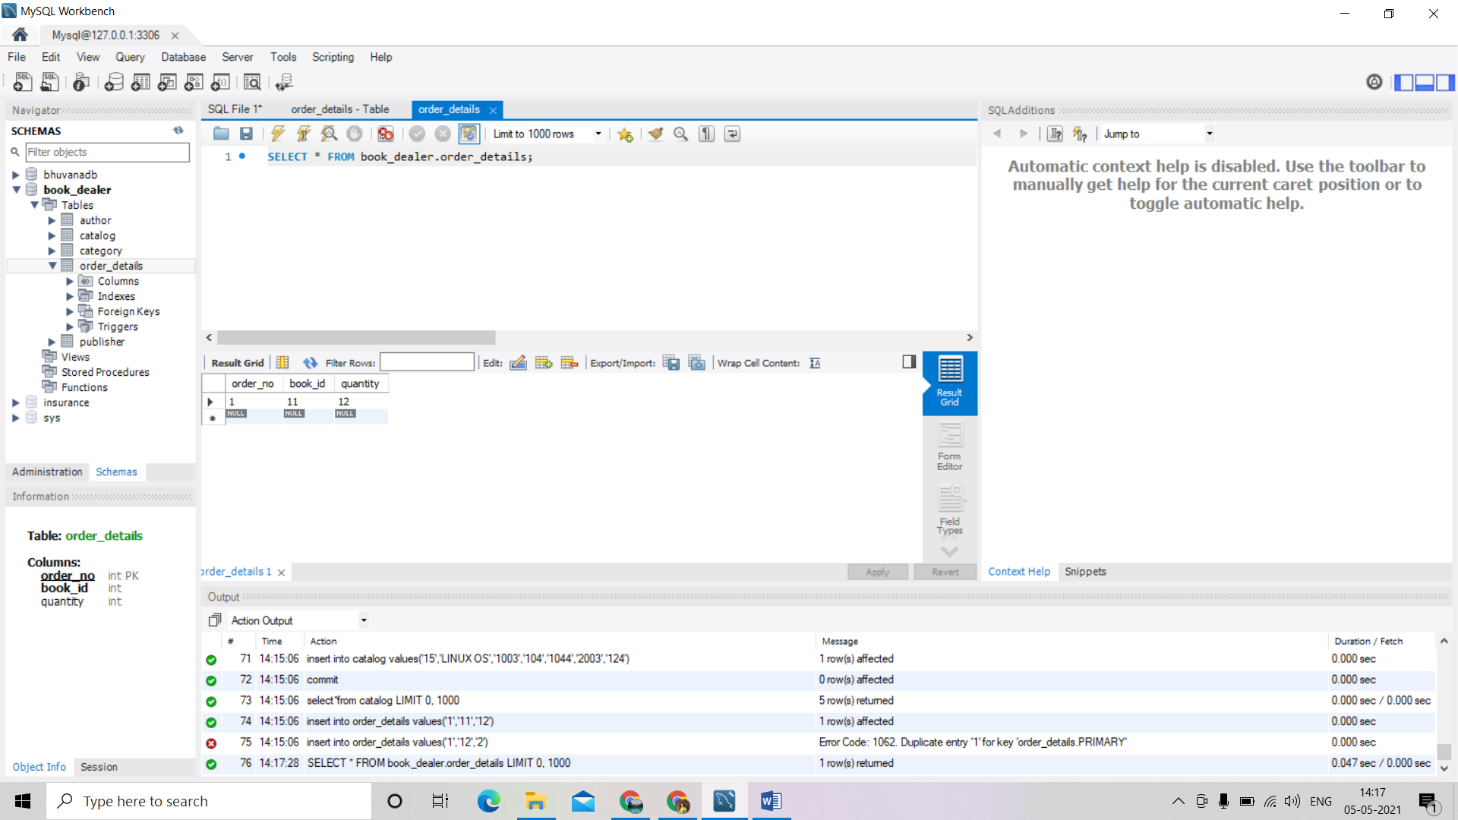

SELECT * FROM book_dealer.author;

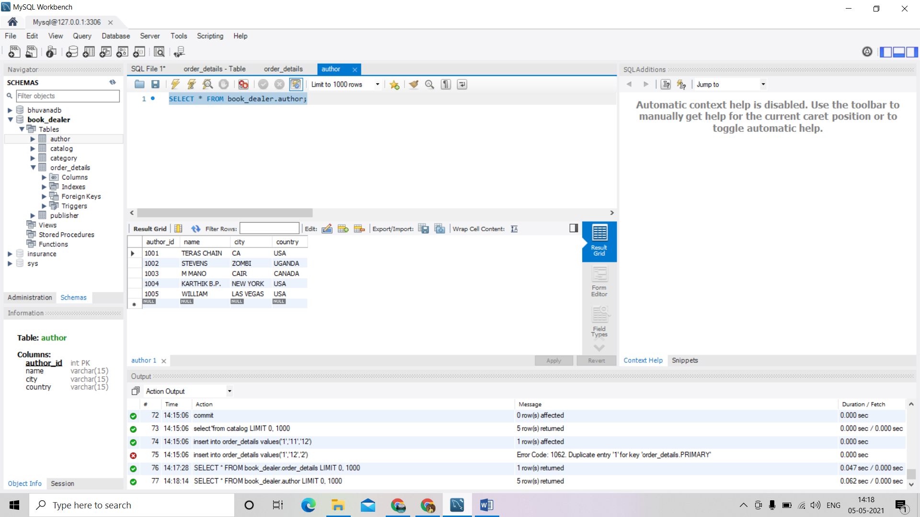

SELECT * FROM book_dealer.catalog;

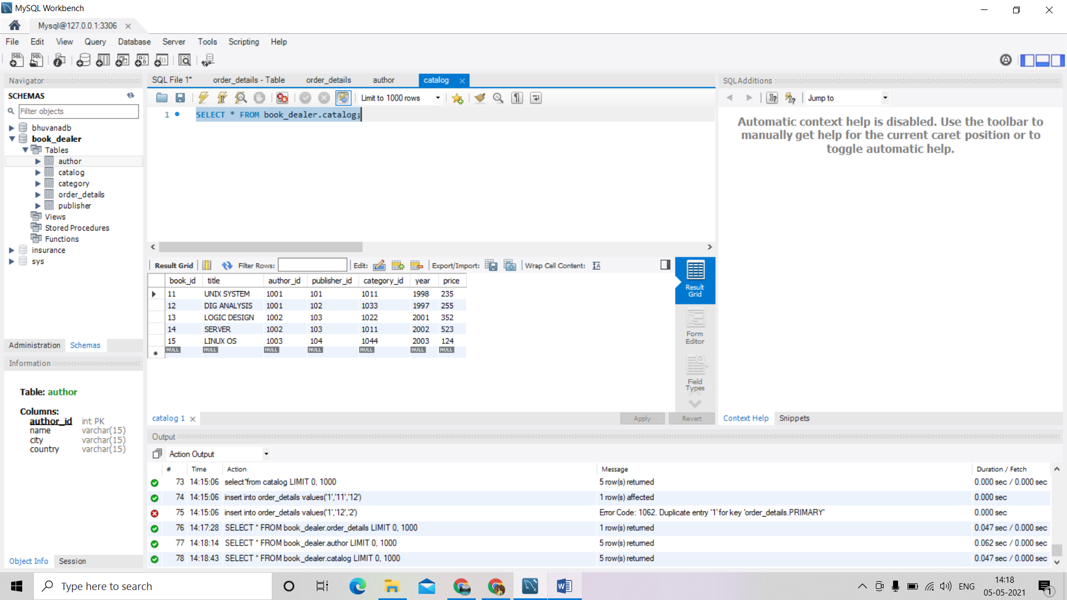

SELECT * FROM book_dealer.category;

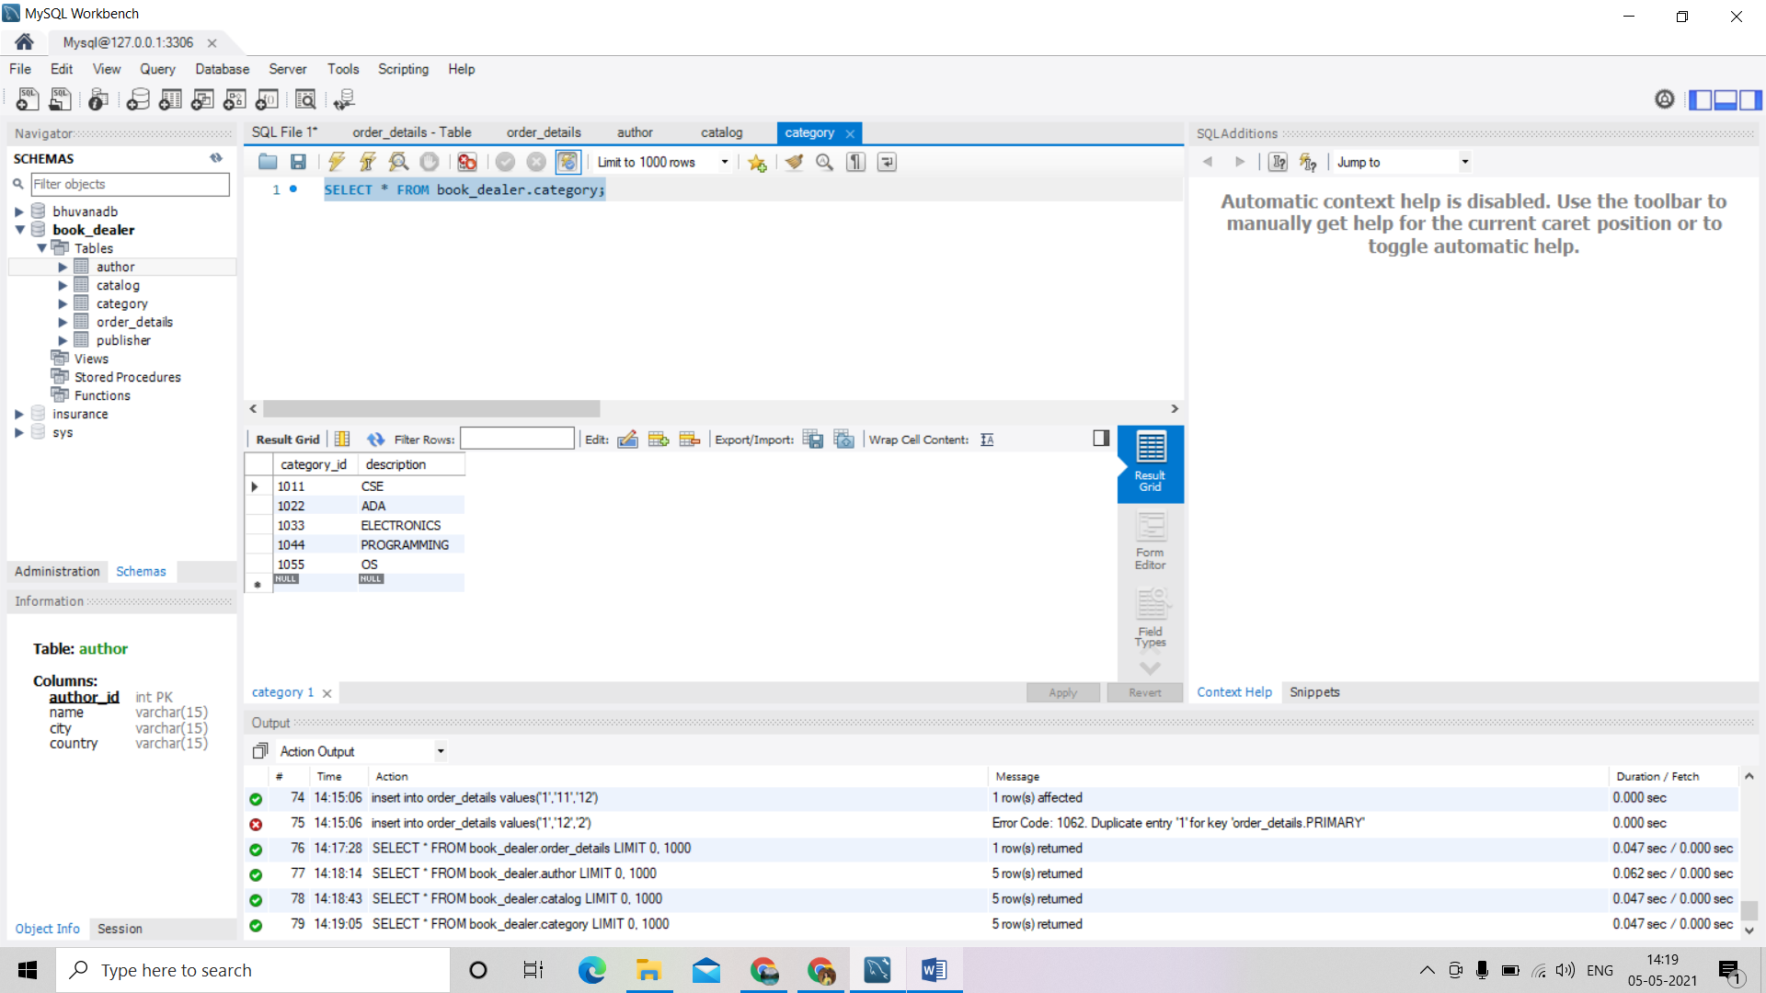

SELECT * FROM book_dealer.publisher;

